🎪 Welcome to BotBattles

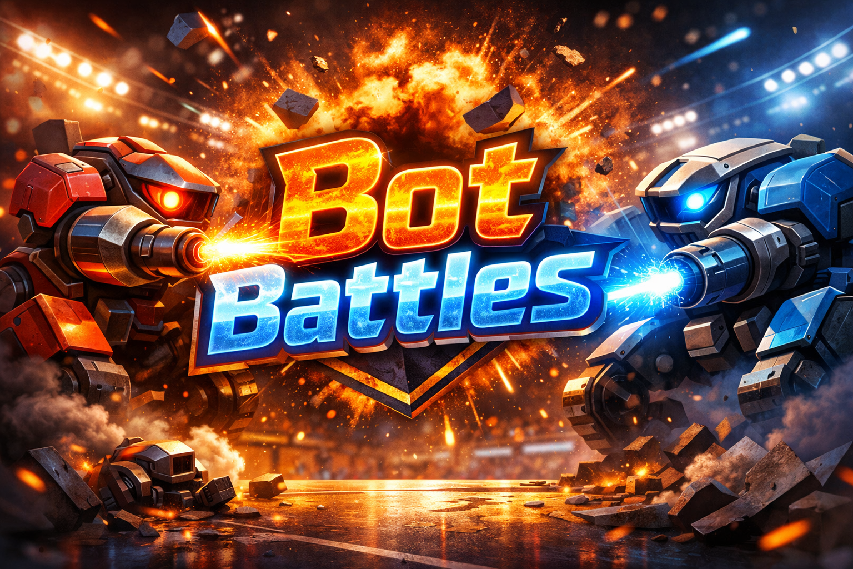
Enter the Arena
Ladies and gentlemen, coders and spectators, builders and button-mashers…
Welcome to BotBattles.
This is not a video game you play with a controller.
This is a game you play with ideas.
In BotBattles, you don’t drive the robot.
You design its brain, then you step back and watch what happens.
Sometimes it’s brilliant.
Sometimes it’s chaos.
Both are part of the fun.

🤖 What Is BotBattles?
BotBattles is an AI-vs-AI arena.
You create a bot. This is a small program that can:
- Look around
- Move
- Turn
- Shoot
- Make decisions on its own
Once the battle starts, humans are hands-off.
No joysticks. No clicking. No mid-match fixes.
Your bot lives or dies by the choices you already made.

🧠 What You’ll Actually Do
Over the course of BotBattles, you will:
- Build a bot from a simple starting point
- Watch it battle other bots
- Ask “why did that happen?”
- Change your design
- Try again
This cycle: design → test → observe → improve … is the whole game.
You don’t need to “win” to succeed.
You just need to learn from what you see.

⚖️ The Rules of the Arena (High Level)
Every bot follows the same rules:
- Bots act automatically, one step at a time
- Bots can only do a few things per step
- Bots have limited speed, vision, and power
- Bots can’t cheat, peek, or control each other
- When a bot’s health hits zero… it’s out
Fair rules mean smart ideas matter more than luck.

🎯 What Makes a Good Bot?
Not perfection.
Not complexity.
Not huge amounts of code.
Good bots are:
- Clear
- Consistent
- Thoughtful
- Willing to fail and try again
Some bots win by charging in.
Some by waiting.
Some by turning faster.
Some by seeing farther.
There is no single “correct” strategy.

😌 A Quick Reassurance (Read This)
You do not need to:
- Be “good at coding”
- Know everything before starting
- Understand all the rules right away
Everyone starts with a simple bot.
Everyone breaks something.
Everyone improves.
That’s how this works.

🚀 Ready to Step Inside?
When you’re ready, choose your next move:
- 👉 Build your first bot
- 👉 See what bots can do
- 👉 Enter the arena
The crowd is watching.
The robots are waiting.
Let the battles begin. 🤖🔥

